Docker Installation on Ubuntu  
  
Uninstall older version of docker installed if any.

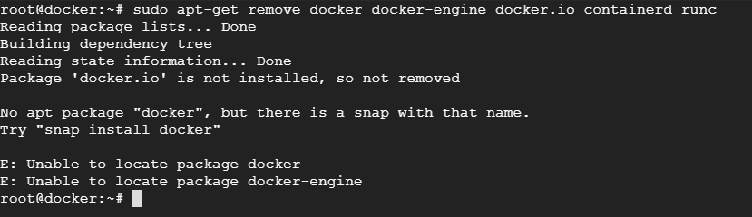

Uninstall

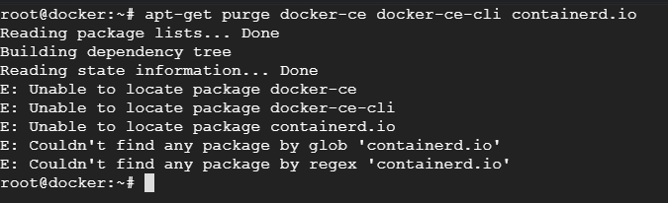  
  
Remove /var/lib/docker/

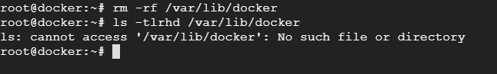

Install docker using repository  
   
i) update the packages

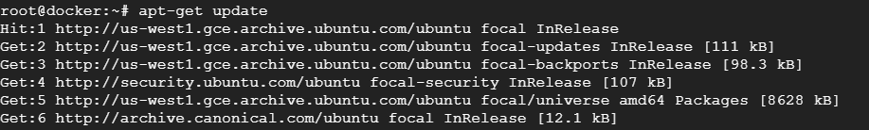

ii) Install the packages

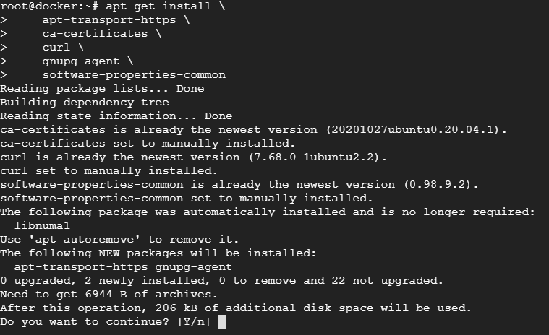

Add dockers official GPG key and verify it

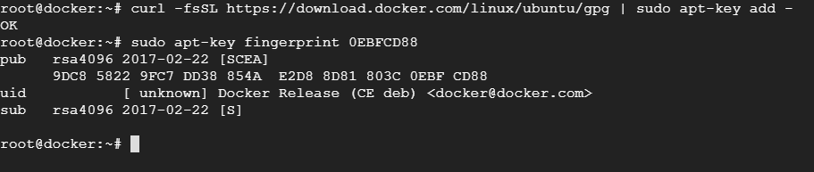  
  
Use the following command to install stable repository

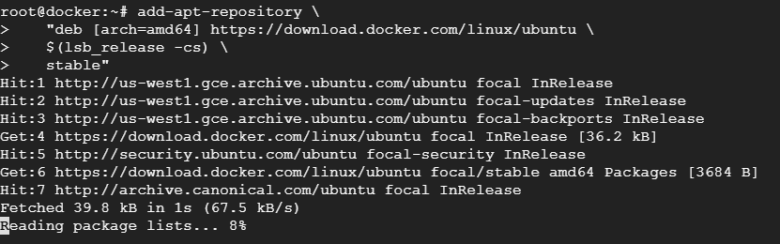  
  
  
  
  
  
Install docker engine  
  
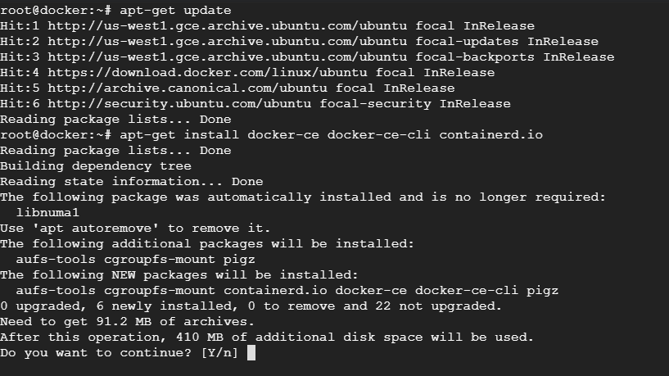

Check docker version and enable to start after server reboot

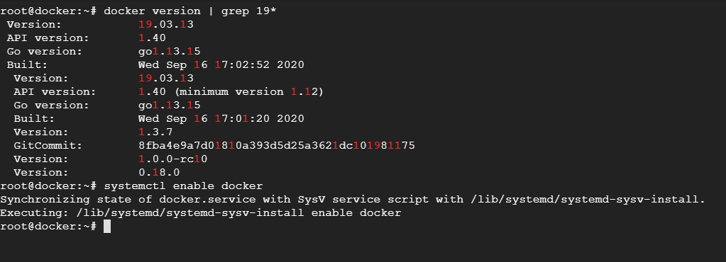

Run docker command and see

